PRESS RELEASE

“URBAN MEMORY BERLIN”. JUAN GARAIZABAL

BERLIN. Bethlehemskirchplatz AND Museum Für KommuniKation

JUNE 26th SEPTEMBER 30th 2012

PRESS CONFERENCE: 11H00. TUESDAY JUNE 26TH.
Museum Für KommuniKation.

OPENING: 19H00. TUESDAY, JUNE 26 th
Museum Für KommuniKation and Bethlehemskirchplatz

DATES: FROM JUNE 26 th TO SEPTEMBER 30 th
SITE SPECIFIC INSTALLATION AT Bethlehemskirchplatz

FROM JUNE 26th TO SEPTEMBER 1st
Museum Für Kommunikation

The Spanish artist Juan Garaizabal gives back the Bohemian Church to the city of Berlin at its original location in Bethlehemskirchplatz with a 31 meter high structure made of steel.

“There are living pasts and dead pasts. Some pasts are the liveliest instigators of the present and the best springboards in to the futur..” Le Corbusier, When the Cathedrals Were White.

The lost Bohemian Bethlehem Church was a unique building in the middle of Berlin, representing one of the most beautiful chapters of the relations between Germany and Bohemia. Thanks to the generosity of King Frederick William I, Czech refugees leaving their homeland for religious reasons were admitted to the Friedrichstadt district of Berlin. The whole story of the church, since its construction in 1733-1735 until today, even though it is absent, is full of values and greatness. It was a monument of the enlightened tolerance who presided over the foundation of the Prussian State.
In 1943, it was badly damaged by bombing. Later, in 1963, the church was demolished and the site incorporated into the facilities of Checkpoint Charlie.

Juan Garaizabal’s “Urban Memory Berlin” is a tribute to the Bohemian settler integrity and to the Prussian generosity. With this intervention the artist seeks to reflect the ability Berlin and its inhabitants have to re-sprout. To do this he takes the most positive essence of the past not only as a differentiating element but also as a lever for a revised and improved future. Thus, the Bethlehemskirche regains its presence to the senses, framing with precision some air that keeps the memory of the element intact, and enabling its use as a place of meeting, reflection and reconciliation.

In parallel to the open air site specific work the Museum Für Kommunikation presents the preparatory artworks of the artist. This exhibit was shown already at the DOX Centre for Contemporary Art in Prague in 2011.

The “Urban Memory Berlin” makes part of Juan Garaizabal’s international project “Urban Memories”. This project focus on recovering and giving worth to architecture elements or historical buildings that have been lost in the course of time. Among these are - the Palais des Tuileries in Paris, Old London Bridge in London, Paço da Ribeira in Lisbon, the Olavide Market in Madrid, San Nicholas Church in New York, Edo Castle Donjon in Tokyo and of course the Bohemian Church of Bethlehem in Berlin.

The “Urban Memories” project is a contemporary and poetic tribute to the disappeared historical and cultural Heritage and an invitation to think on the importance of its preservation for the human beeing present and future.

Using a steel construction fitted with light, Garaizabal shows the spirit of the vanished buildings in its original location and in a scale 1:1.

My “Urban Memories” are large format artistic installations that aim at recreating the spirit of vanished constructions; buildings which had great value in their time. (…)
To understand and feel my work there is no need to read. However once you are in contact with it you only want to hold up the archives*.

Each of these and other monumental sculptural installation projects require him to explore the most varied artistic techniques in all type of preparatory work: photos, drawings, models, silk screens...

To help finding contributions to this heroic project besides the preparatory work on show at the Museum für Kommunikation, Juan Garaizabal offers the possibility to buy an original work for 100 euros: “Bohemian Church Berlin now vs.then for contributors”, a 70 x 100 cm collage teared and painted by hand.

On the occasion of this project and invited by the photo festival PhotoEspaña 2012 he will have at the same time a solo show based in “Urban Memories” at Galería Alvaro Alcazar (Madrid) www.galeriaalvaroalcazar.com

Juan Garaizabal (Madrid, 1971) is a conceptual artist specialized in the creation and transformation of interactive spaces as a mean of artistic communication. He lives and works in Madrid and Berlin.

*Juan Garaizabal

WITH THE SUPPORT:
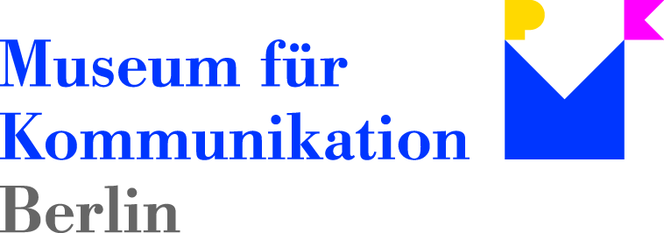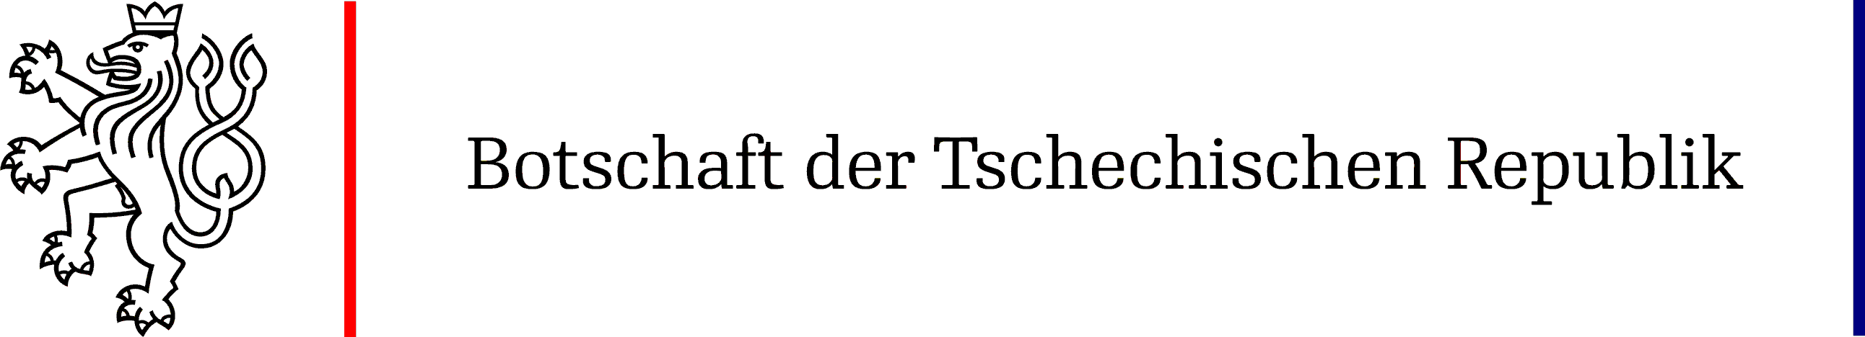

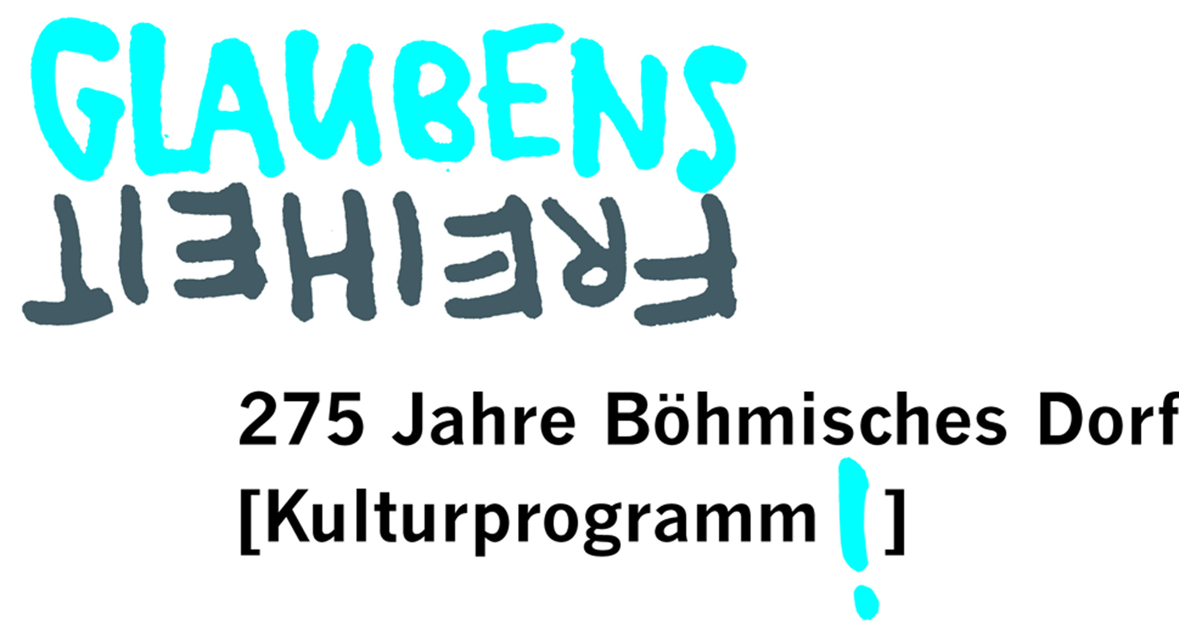

In collaboration with:

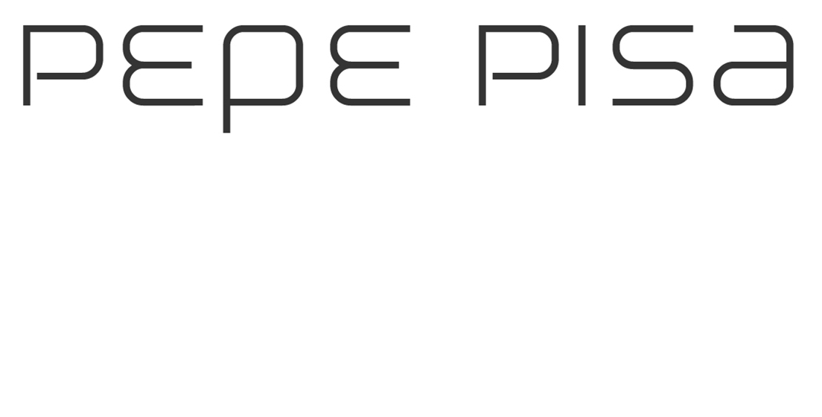

FOR MORE INFORMATION AND IMAGES:

QR www.memoriasurbanas.com or contact Pia Ogea: p@piaogea.com

OPENING HOURS AND ADMISSION
SITE SPECIFIC INSTALLATION AT Bethlehemskirchplatz
CAN BE VISITED 24H/24H. FREE ADMISSION Mauerstr 81-82 D-10117 Berlin

Museum Für Kommunikation
Opening hours: Mon Closed Tue 09:00-20:00 Wed 09:00 -17:00
Thu 09:00 -17:00 Fri 09:00 -17:00 Sat 10:00-18:00 Sun 10:00 -18:00
Admission: 3,00 Euro Reduced: 1,50 Euro Leipziger Straße 16 10117 Berlin

